**Project report**

**1.Introduction**

**1.1** overview

Customer relationship management (CRM) is an approach to manage a company's interaction with current and potential customers. It uses data analysis about customers' history with a company to improve business relationships with customers, specifically focusing on customer retention and ultimately driving sales growth.

1.2 ***purpose***

CRM software lets you store customer and prospect contact information, identify sales opportunities, record service issues, and manage marketing campaigns, all in one central location — and make information about every customer interaction available to anyone at your company who might need it. The ultimate goal of customer relationship management (CRM) software is to personalize individual customer experiences at every point along their journey from prospect to repeat buyer, increasing brand loyalty and the company's bottom

Another important aspect of the CRM spectrum is [marketing automation](https://www.higher-education-marketing.com/blog/beginners-guide-marketing-automation-education), which enables your team to automate certain processes across different digital channels.  While they are technically two different areas, CRM and marketing automation often intertwine, as they both serve to provide tools to help nurture leads down the funnel towards conversion.

1. 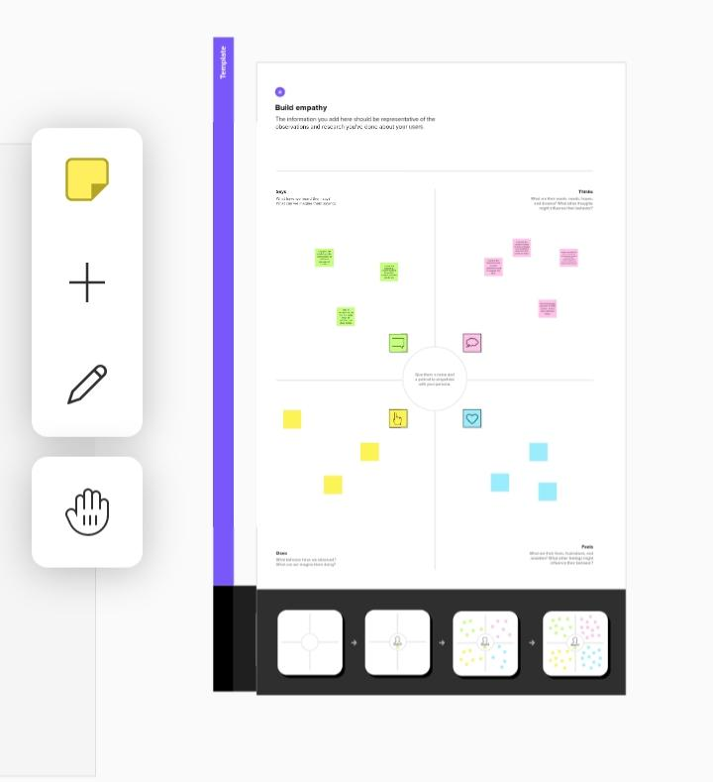**problem definition and design thinking 2.1 empathy map**

**2.2idea thinking and brainstorming:**

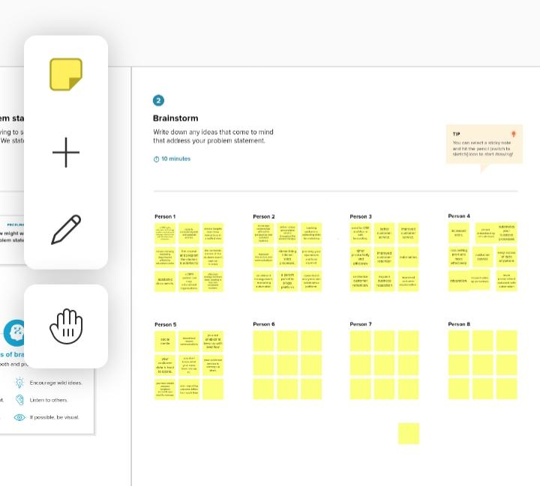

# Result

**3.1 Data model**

|  |  |  |  |  |
| --- | --- | --- | --- | --- |
| **Object** | **Fields** **lable** | | | |
| School  Student |  | **Address** | **Text area** |  |
| District | Text area |
| State | Text area |
| School websites | Text area |
| Phone number  Number of students  Highest mark  Phone number  School  Result  Class  Marks  Parent address  Parent number | Phone  Roll up summary  Roll up summary  Phone  Master detail relationship  Picklist  Number  Number  Text area  Phone |
|  |  |  |  |  |

**Project Activities**

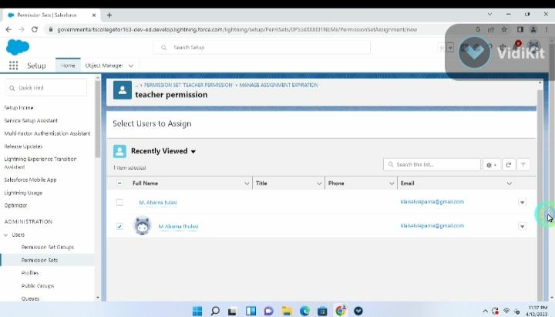

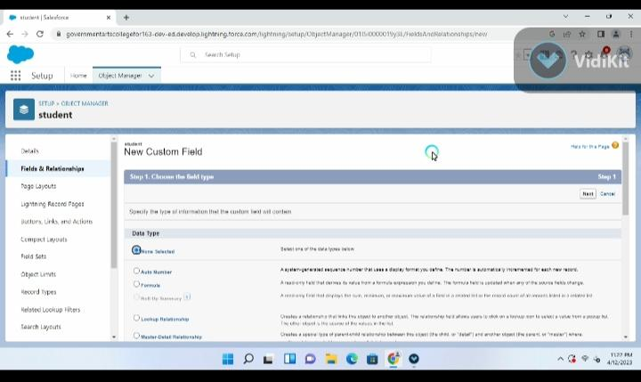

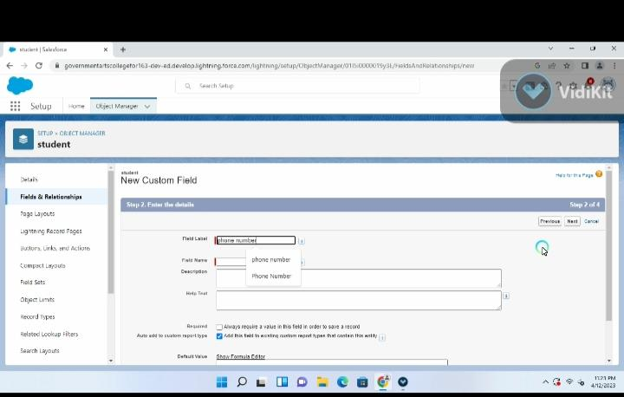

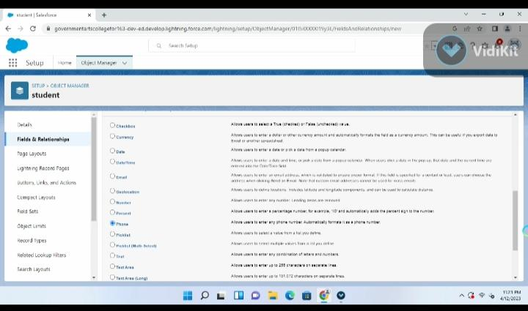

**Trailhead Profile public URL:**

Team leader: <https://trailblazer.me/id/asoundari>

Team member 1: <https://trailblazer.me/id/akalaiselvi>

Team member 2: <https://trailblazer.me/id/gmani126>

Team member 3: <https://trailblazer.me/id/ggowsika1>

Team leader 4: <https://trailblazer.me/id/viveka33>

ADVANTAGES

* Automates processes.
* Streamlines the billing process.
* Supports professional development.
* Helps you recognise top employees or clients.
* Increases productivity.
* Job progress analysis.
* Team tracking.
* Syncing across devices

**DISADVANTAGES**

* CRM costs. One of the greatest challenges to CRM implementation is cost. ...
* Business culture. A lack of commitment or resistance to cultural change from

people within the company can cause major difficulties with CRM implementation. ...

* Poor communication. ...
* Lack of leadership.

## CONCLUSION

### Conclusion. Customer Relationship Management enables a company to align its strategy with the needs of the customer in order to best meet those needs and thus ensure long-term customer loyalty

### Customer relationship management (CRM) is a technology for managing all your company's relationships and interactions with customers and potential customers. The goal is simple: Improve business relationships. A CRM system helps companies stay connected to customers, streamline processes, and improve profitability.

### FUTURE SCOPE

The future of CRM] is about which companies will be able to pivot to meet the changing needs and trends — driven by customer expectations. Customers expect organizations to know a lot about them and expect to have conversations. Companies like Tact.ai and Nimble on the sales side are solid examples.